Southern Morning Prayer:
About Southern Morning Prayer

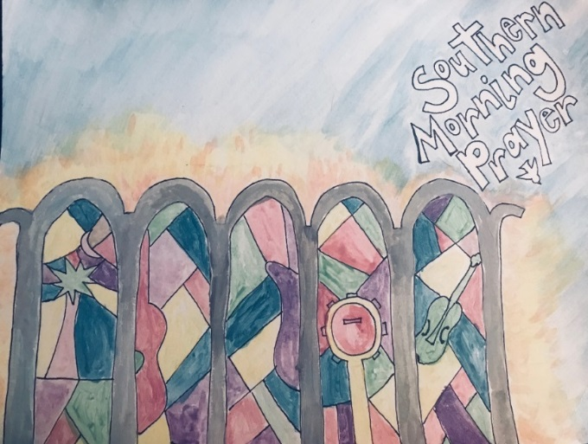

Of the eight original canonical hours, three remain in common use in Protestant churches: Evening Prayer (originally called Vespers), Night Prayer (originally called Compline), and Morning Prayer (which is a combination of the original Matins, Lauds, and Prime). Each of the three services has elements that are peculiar to them.

Morning Prayer traditionally uses either the Benedictus (from Luke 1), or the Te Deum (a creedal prayer that dates to the fourth century). Southern Morning Prayer uses the Te Deum (“We praise you, God” on page 7). Portions of Psalm 51 (pages 2-3), and the Venite (based on Psalm 95, pages 5-6) are also traditional elements of Morning Prayer.

Southern Morning Prayer was written, revised, and recorded from 2015—2018 by seminary students at Lutheran Theological Southern Seminary.

The artwork is a representation of the stain glass windows at Christ Chapel on the campus of Lutheran Theological Southern Seminary; note how instruments used in the recording are imaginatively place in the windows.

803.786.5150
4201 North Main Street
Columbia SC 29203
www.lr.edu/ltss

Special thanks go to
- The Auxiliary of Lutheran Theological Southern Seminary for production funding,
- Gary Bolton for being our excellent and gracious recording technician at
Strawberry Skys Recording Studio (strawberryskys.com)
- Rev. Flavian Coleman for suggesting Strawberry Skys as our recording studio,
- and Clay Schmit for spit-balling.

